THE RESEARCH DATA ALLIANCE AND GENDER

What are the main RDA policies on gender and how do you implement them, e.g. do Working Groups have to have men and women as co-chairs?
The Research Data Alliance does not, at this time, have an official policy or criteria for gender balance in groups, nor in Council, TAB, OAB, etc membership. However, we strive to ensure gender balance where possible, particularly in relation to the Plenary meetings where we always seek balance across speakers, panels, and when seeking nominations for chairs. TAB, OAB and Council members we always keep the gender balance issue forefront in our minds and work quite hard to encourage potential female candidates.

How many individual members does RDA have and what is the gender balance?
Upon registering as a member for RDA, we do not ask for gender as a field. We do however, require that information when registering for plenary meetings and below are some statistics on the last plenaries:
Plenary | Location | Date | Total | Male No. | Female (No.) | Did not disclose (no.)
P11 | Berlin | 21-23 March 2018 | 661 | 381 | 261 | 19
P10 | Montreal | 19-21 Sept 2017 | 436 | 236 | 193 | 7
P9 | Barcelona | 5-7 April 2017 | 610 | 377 | 233 | 0
P8 | Denver | 11-17 Sept 2016 | 549 | 335 | 214 | 0
P7 | Tokyo | 1-3 March 2016 | 364 | 258 | 106 | 0
P6 | Paris | 23-25 Sept 2015 | 711 | 455 | 256 | 0

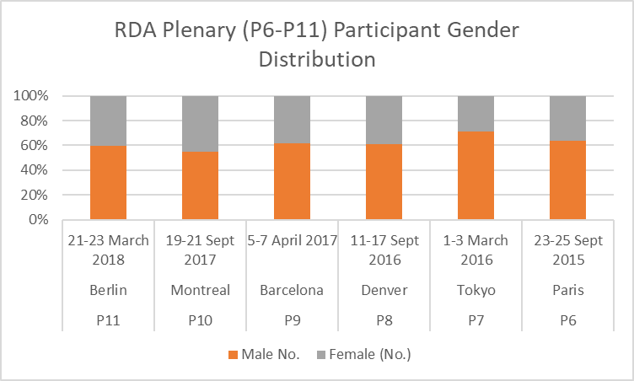

How many interest/working groups do you have and what is the gender balance of the chairpersons?
As of 31 May 2018:
- Total Groups = 91 of which 33 Working Groups and 51 Interest Groups
- 180 male / 110 female group chair “slots” (i.e., a person co-chairing several groups is counted separately each time). This is a total of 37.93% female.
- There are 26 groups (i.e., 28.57% of all groups) with all-male and 9 (i.e., 9.89% of all groups) groups with all-female co-chairs.
In August 2017, we had 35.47% female co-chair slots so there has been a slight increase in the past 8 months.

What are the key constituencies/professions represented in RDA – computer science, librarianship etc.?
The graph below indicates the role / qualification of the RDA individual members (as of 1st May 2018, there are 6,952 members. The membership data is updated on a monthly basis and can be downloaded on the RDA web site on the “Who is RDA” web page.
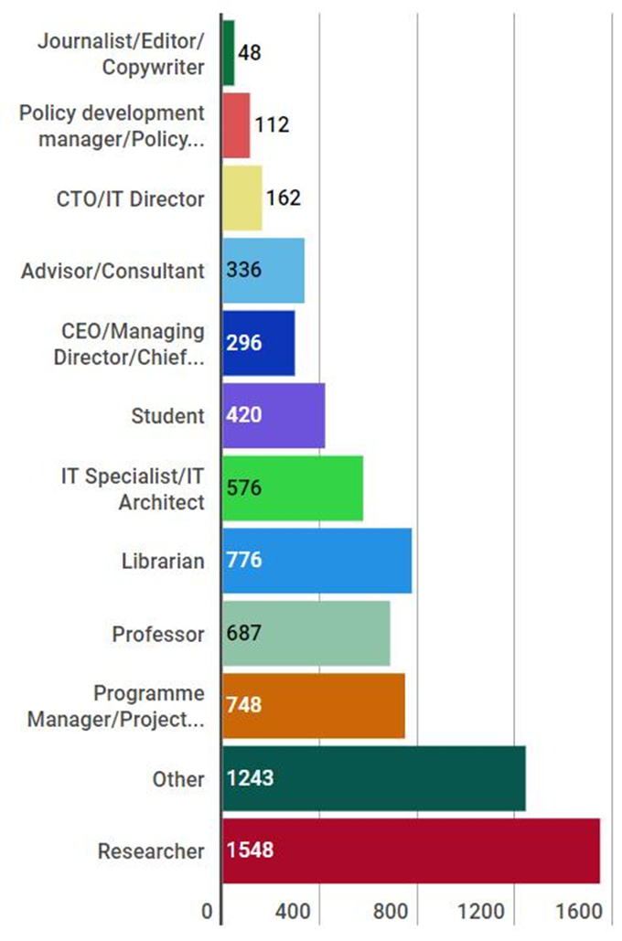

Any other relevant facts and figures that you have readily to hand?
The Research Data Alliance, since the 5th Plenary Meeting in San Diego (March 2015), organises a Women in RDA networking event during the plenary and all female participants are invited to attend.
As a result of these networking meetings, a task force on gender diversity in RDA has been set up.

CURRENT gender balance of the RDA governance boards
The RDA has a simple governance structure consisting of four main bodies, and the gender balance, as of 10 June 2018, is outlined below. Both the Council and the Technical Advisory Board are elected by the members, based on nominations. The Organisation Advisory Board is elected by the Organisational Assembly (made up of the organisational members) and the Secretariat staff are provided by the regions supporting RDA. The Secretary General is contracted directly and follows a job application / selection process.
Board | Total | Male No. | Female (No.) | Male Co-chairs | Female Co-chairs | Elected
Council | 9 | 3 | 6 | 1 | 1 | Yes
Technical Advisory Board | 13 | 7 | 6 | 1 | 1 | Yes
Organisational Advisory Board | 8 | 7 | 1 | 1 | 1 | No: nominated
Secretariat | 10 | 2 | 8 | 0 | 0 | No: in kind
Secretary General | 1 | 0 | 1 | 0 | 0 | No: contracted

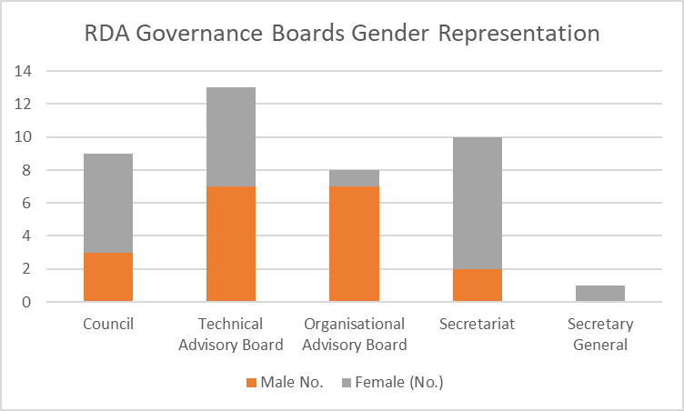

Source: RDA web Registration pages for each Plenary
Source: https://www.rd-alliance.org/groupdetails
http://www.rd-alliance.org/about-rda/who-rda.html

